This is the last entry in Flo Treadwell’s Diary. Although it states 1893, it is actually for 1895!

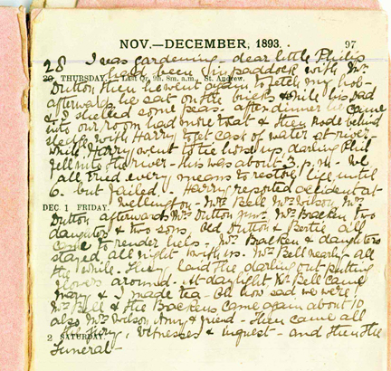

28th November 1895.

I was gardening – dear little Philip had been in paddock with Mr Dutton then he went again to fetch my hob – afterwards he sat on the bricks while his Dad and I shelled some peas. After dinner he came into our room had more to eat & then rode behind sledge with Harry to get cask of water at river – while Harry went to tie horse up, darling Phil fell into the river – this was about 3pm. We all tried every means to restore life, until 6 but failed – Harry reported accident at Wellington – Mrs Bell, Mrs Wilson, Mrs Dutton afterwards Mrs Dutton jnr, Mrs Bracken daughters and two sons, Old Dutton and Bertie all came to render help – Mrs Bracken & Daughters stayed all night with us. Mrs Bell nearly all the while. They laid the darling out putting flowers around. At daylight, Mrs Bell came Mary & I made tea – oh how sad we were. Mrs Bell & the Brackens came again about 10 also Mrs Wilson, Amy & friend – Then came all the jury, witnesses & inquest – and then the funeral -

